Bolsover & District Cycling Club HARDWICK HALL HILL CLIMB – with great thanks to our hosts National Trust Hardwick Hall
Sunday 10th September 2023 7.30 pm
COURSE : OHC 11
START 19:31 HRS HQ – Hardwick Hall, S44 5QJ.
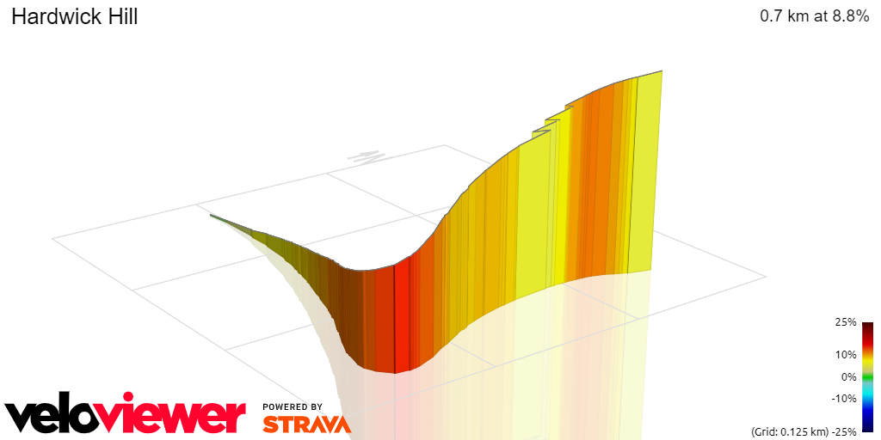

A great evenings racing under lights, and the threat of thunderstorms passed with no rain during the race at Hardwick Hall on Sunday night. The Hill is usually closed to riders as it is the one way exit for visitors. The climb is 615 metres long with a 55-metre climb mainly in the last third which includes a cattle grid.
Earlier rain left it a bit greasy for the early starters but all 9 juveniles led off by three 9 year olds including Bolsover's very Own Albie Saxton (3:18) whilst Max Parish (2:40) and George Anthony (2:33) showed impressive racing style on the night.
The strength of the field was highlighted by 4 juveniles going sub two minutes
Tom Lindley | Team Sheffield | 00:01:47
Samuel Price | Ilkeston Cycle Club | 00:01:48
Jude Alcock | Sheffield Youth Cycling Club | 00:01:53
Thomas Wray | Ilkeston Cycle Club | 00:01:54

FEMALES
In a small female field Emilie Verroken returned to the top of the podum with a 1 second improvement on her 2021 and 2022 times; followed by the ageless Yvonne Twelvetrees taking 11 seconds off her 2022 time whilst Bolsover's Brompton Crew – Sonia and JLeo showed what is possible on a fold up bike
Emilie Verroken | Team Lifting Gear Products | 00:01:57
Yvonne Twelvetree | Sheffield Triathlon Club | 00:03:19
Julie Leonardo | Bolsover and District CC | 00:03:37
Sonia Insley | Bolsover and District CC | 00:03:40

.
As it got darker times got faster and event regulars and previous podium toppers battled it out.
Calum Brown | Team Lifting Gear Products | 00:01:19:9
Gregg Booker | SUMMAT CC | 00:01:23:6
Andy Nichols | Team Lifting Gear Products | 00:01:23:7

Two minutes is a great target for male riders with over two thirds of the adult male field achieving this
Please feel free to share your photos with us.

Full results by start time
Albie Saxton | Bolsover and District CC | 00:03:18
Max Parish | Ilkeston Cycle Club | 00:02:40
George Anthony | Matlock CC | 00:02:33
Finn Miller | Matlock CC | 00:02:41
Jude Alcock | Sheffield Youth Cycling Club | 00:01:53
Thomas Wray | Ilkeston Cycle Club | 00:01:54
Samuel Price | Ilkeston Cycle Club | 00:01:48
Tom Lindley | Team Sheffield | 00:01:47
Sonia Insley | Bolsover and District CC | 00:03:40
Julie Leonardo | Bolsover and District CC | 00:03:37
Emilie Verroken | Team Lifting Gear Products | 00:01:57
Lawrence Gillam | Belper BC | 00:01:42
Sean Reek | Ilkeston Cycle Club | 00:02:04
Nick Baggaley | Nottingham Clarion CC | 00:02:03
Rob Tomlinson | South Normanton C C | 00:02:20
Yvonne Twelvetree | Sheffield Triathlon Club | 00:03:19
Jonathan Pupius | 7 Hills Cycling Club | 00:02:25
Benjamin Manwaring | South Normanton C C | 00:01:59
Andy Smith | Mansfield Road Club | 00:02:12
Gary Morrison | South Normanton C C | 00:02:17
Robert Sansby | Leicestershire RC | 00:01:43
Steven Hazeldine | Stone Wheelers CC | 00:02:05
Niall Read | South Normanton C C | 00:01:59
Dale Wilkes | Mansfield Road Club | 00:02:26
Anthony McNamara | Rockingham CC | 00:02:37
Michael Bunn | Rockingham CC | 00:02:35
David Lane | Ravensthorpe CC | 00:02:50
Josh Stringfellow | Virtual Cycling Club | 00:01:48
Laurie Stobbs | Trek Bicycles Bakewell | 00:01:59
Alan Royle | 7 Hills Cycling Club | 00:01:39
Chris Myhill | Peak Road Club | 00:01:45
Daniel Farrand | TrueSapien | 00:01:59
Chris Kaye | Ilkeston Cycle Club | 00:02:01
Gavin Alcock | 7 Hills Cycling Club | 00:01:57
Timothy Lane | University of Nottingham C C | 00:01:47
James Lonsdale | Bolsover and District CC | 00:01:44
Oliver Humphreys | National Clarion CC | 00:01:42
Andrew Askwith | Vive Le Velo | 00:02:01
Charlie Openshaw | Team Lifting Gear Products | 00:01:43
James King | OVB | 00:01:31
Joseph Walker | Belper BC | 00:01:39
Darren Miller | Fusion Cycling Club Dronfield | 00:01:57
Noah Starbuck | Sleaford Wheelers Cycling Club | 00:01:40
Ethan Squires | Beeston Cycling Club | 00:01:38
James Hayward | Woolwich CC | 00:01:35
Lewis Smith | Sheffield Youth Cycling Club | 00:01:38
Andy Nichols | Team Lifting Gear Products | 00:01:23
Nicholas Latimer | Team Lifting Gear Products | 00:01:37
Isaac Oliver | Sheffield Youth Cycling Club | 00:01:33
Ewen Ross | SUMMAT CC | 00:01:51
Calum Brown | Team Lifting Gear Products | 00:01:19
Gregg Booker | SUMMAT CC | 00:01:23

